caXchange HL7v3 Data Types Framework Design

1. Introduction

Project Background:

The BRIDG messages service need to be created as a GRID service according to the requirement. The BRIDG messages are using HL7 v3 data types as their basic data types. So, the HL7 data types need to be created and be registered as part of the caGRID Data Types. Therefore, the BRIDG messages service can send and receive messages based on the GRID services.

The implementation of the HL7v3 data types will be provided to the caGrid team to facilitate a future implementation that would allow these data types to be used as attributes of an object.

System Overview:

caGRID client and services in caBIG communicate through the GRID using respectively Globus GRID clients and service infrastructure. The GRID communication protocol is XML, and thus the client and service APIs must transform the transferred objects to and from XML.

HL7 v3 Data Type Serialization Framework is developed to support HL7 v3 data type object’s XML serialization functionality. Each HL7 v3 data type object can travel on the GRID when it adheres to a registered XML schema. Thus, HL7v3 data types can be part of the BRIDG message services whose provision is via caGrid Globus.

2. System Architecture

HL7 v3 Data Type Framework includes following components:

- HL7 v3 data type beans: The data type beans are the implementation of HL7 v3 2006 Edition data type specification, which are leveraging HL7 JavaSIG open source.

- HL7 v3 data type schema: The XML schemas (XSDs) are used both to describe the contract of the service and to validate the XML serialization of the objects.

- Serialization Framework: It allows HL7 v3 data type objects to be serialized to XML and de-serialized back from XML.

Once these components are completed, the other teams will be able to use these objects within their own GRID services.

3. Components

3.1 HL7 v3 data type beans

Every data element has a data type. Data types define the meaning (semantics) of data values that can be assigned to a data element. HL7 data types includes the following:

Table 1: Overview of HL7 version 3 data types
Name | Symbol | Description
DataValue | ANY | Defines the basic properties of every data value. This is an abstract type, meaning that no value can be just a data value without belonging to any concrete type. Every concrete type is a specialization of this general abstract DataValue type.
Boolean | BL | BL stands for the values of two-valued logic. A BL value can be either true or false, or, as any other value may be NULL.
BooleanNonNull | BN | BN constrains the boolean type so that the value may not be NULL. This type is created for use within the data types specification where it is not appropriate for a null value to be used
Encapsulated Data | ED | Data that is primarily intended for human interpretation or for further machine processing outside the scope of HL7. This includes unformatted or formatted written language, multimedia data, or structured information in as defined by a different standard (e.g., XML-signatures.) Instead of the data itself, an ED may contain only a reference (see TEL.) Note that ST is a specialization of the ED where the mediaType is fixed to text/plain.
Character String | ST | The character string data type stands for text data, primarily intended for machine processing (e.g., sorting, querying, indexing, etc.) Used for names, symbols, and formal expressions.
Concept Descriptor | CD | A CD represents any kind of concept usually by giving a code defined in a code system. A CD can contain the original text or phrase that served as the basis of the coding and one or more translations into different coding systems. A CD can also contain qualifiers to describe, e.g., the concept of a "left foot" as a postcoordinated term built from the primary code "FOOT" and the qualifier "LEFT". In cases of an exceptional value, the CD need not contain a code but only the original text describing that concept.
Coded Simple Value | CS | Coded data in its simplest form, where only the code is not predetermined. The code system and code system version are fixed by the context in which the CS value occurs. CS is used for coded attributes that have a single HL7-defined value set.
Coded Ordinal | CO | Coded data, where the coding system from which the code comes is ordered. CO adds semantics related to ordering so that models that make use of such domains may introduce model elements that involve statements about the order of the terms in a domain.
Coded With Equivalents | CE | Coded data that consists of a coded value and, optionally, coded value(s) from other coding systems that identify the same concept. Used when alternative codes may exist.
Character String with Code | SC | A character string that optionally may have a code attached. The text must always be present if a code is present. The code is often a local code.
Instance Identifier | II | An identifier that uniquely identifies a thing or object. Examples are object identifier for HL7 RIM objects, medical record number, order id, service catalog item id, Vehicle Identification Number (VIN), etc. Instance identifiers are defined based on ISO object identifiers.
Telecommunication Address | TEL | A telephone number (voice or fax), e-mail address, or other locator for a resource mediated by telecommunication equipment. The address is specified as a Universal Resource Locator (URL) qualified by time specification and use codes that help in deciding which address to use for a given time and purpose.
Postal Address | AD | Mailing and home or office addresses. A sequence of address parts, such as street or post office Box, city, postal code, country, etc.
Entity Name | EN | A name for a person, organization, place or thing. A sequence of name parts, such as given name or family name, prefix, suffix, etc. Examples for entity name values are "Jim Bob Walton, Jr.", "Health Level Seven, Inc.", "Lake Tahoe", etc. An entity name may be as simple as a character string or may consist of several entity name parts, such as, "Jim", "Bob", "Walton", and "Jr.", "Health Level Seven" and "Inc.", "Lake" and "Tahoe".
Trivial Name | TN | A restriction of entity name that is effectively a simple string used for a simple name for things and places.
Person Name | PN | An EN used when the named Entity is a Person. A sequence of name parts, such as given name or family name, prefix, suffix, etc. A name part is a restriction of entity name part that only allows those entity name parts qualifiers applicable to person names. Since the structure of entity name is mostly determined by the requirements of person name, the restriction is very minor.
Organization Name | ON | An EN used when the named Entity is an Organization. A sequence of name parts.
Integer Number | INT | Integer numbers (-1,0,1,2, 100, 3398129, etc.) are precise numbers that are results of counting and enumerating. Integer numbers are discrete, the set of integers is infinite but countable. No arbitrary limit is imposed on the range of integer numbers. Two NULL flavors are defined for the positive and negative infinity.
Real Number | REAL | Fractional numbers. Typically used whenever quantities are measured, estimated, or computed from other real numbers. The typical representation is decimal, where the number of significant decimal digits is known as the precision.
Ratio | RTO | A quantity constructed as the quotient of a numerator quantity divided by a denominator quantity. Common factors in the numerator and denominator are not automatically cancelled out. The RTO data type supports titers (e.g., "1:128") and other quantities produced by laboratories that truly represent ratios. Ratios are not simply "structured numerics", particularly blood pressure measurements (e.g. "120/60") are not ratios. In many cases the REAL should be used instead of the RTO.
Physical Quantity | PQ | A dimensioned quantity expressing the result of measuring.
Monetary Amount | MO | An MO is a quantity expressing the amount of money in some currency. Currencies are the units in which monetary amounts are denominated in different economic regions. While the monetary amount is a single kind of quantity (money) the exchange rates between the different units are variable. This is the principle difference between PQ and MO, and the reason why currency units are not physical units.
Point in Time | TS | A quantity specifying a point on the axis of natural time. A point in time is most often represented as a calendar expression.
Set | SET | A value that contains other distinct values in no particular order.
Sequence | LIST | A value that contains other discrete (but not necessarily distinct) values in a defined sequence.
Bag | BAG | An unordered collection of values, where each value can be contained more than once in the collection.
Interval | IVL | A set of consecutive values of an ordered base data type.
History | HIST | A set of data values that have a valid-time property and thus conform to the HXIT type. The history information is not limited to the past; expected future values can also appear.
Uncertain Value - Probabilistic | UVP | A generic data type extension used to specify a probability expressing the information producer's belief that the given value holds.
Periodic Interval of Time | PIVL | An interval of time that recurs periodically. PIVL has two properties, phase and period. phase specifies the "interval prototype" that is repeated every ..
Event-Related Periodic Interval of Time | EIVL | Specifies a periodic interval of time where the recurrence is based on activities of daily living or other important events that are time-related but not fully determined by time.
General Timing Specification | GTS | A <dt-TS>, specifying the timing of events and actions and the cyclical validity-patterns that may exist for certain kinds of information, such as phone numbers (evening, daytime), addresses (so called "snowbirds," residing closer to the equator during winter and farther from the equator during summer) and office hours.
Parametric Probability Distribution | PPD | A generic data type extension specifying uncertainty of quantitative data using a distribution function and its parameters. Aside from the specific parameters of the distribution, a mean (expected value) and standard deviation is always given to help maintain a minimum layer of interoperability if receiving applications cannot deal with a certain probability distribution.

Also, please see the following, the UML representation of the HL7 data types.

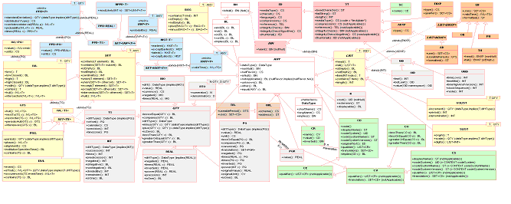
Figure 1 HL7 v3 data type UML Model

caXchange HL7 data type java bean implementation leverages the Java SIG open source, which includes Interfaces as well as its implementation.

3.2 HL7 v3 data type Schema

caBIG requires that the inputs and outputs of service operations use only registered objects, these input and output data types are defined by the XML schemas. The HL7 v3 data type schemas (XSDs) are used both to describe the contract of the service and to validate the XML serialization of the objects.

We create HL7 v3 data type schemas, which are also based on HL7 v3 2006 normative edition.

3.3 HL7 v3 data type Serialization Framework
caGRID objects must serialize to and from XML as they traverse the GRID. Standard Globus Serialization caGrid is built using the Globus 4 toolkit. The Globus toolkit has a complete set of tools for automatic generation of serializable objects using models defined in XML schemas. Using this mechanism, Globus has the ability to automatically create a set of Java Beans which represent this model and will be able to be serialized and deserialized automatically at client and service runtime via the Globus toolkit with no extra configuration. In order to use these types in a grid service, the developer must describe the types that they will be using in the WSDL file. This will enable Globus to locate the types, and generate the required beans during stub generation time. Using this approach, the object-oriented client and service APIs are written using the Globus generated Java Objects. The toolkit will automatically serialize and deserialize the Objects as they travel to and from the GRID.
However, caXchange already has HL7 JavaSIG java object model. Therefore, a custom serialization framework needs to be developed and configured at the Globus service site and client site to be able to use the custom serialization.
The Globus type-mapping configuration needs to be configured in the services WSDD and in the client’s WSDD. If a user has a data type called II, which has its own serialization, then the following configuration must be placed in the service WSDD as well as in the client WSDD:
<service …>
…
<ns3:typeMapping xmlns:ns1="http://xml.apache.org/axis/wsdd/providers/java" xmlns:ns2="urn:hl7-org:v3" xmlns:ns3="http://xml.apache.org/axis/wsdd/"/>
encodingStyle="" type="ns1:org.hl7.types.II" " qname="ns2:II" serializer="gov.nih.nci.caxchange.hl7v3datatype.encoding.DatatypeSerializerFactory" deserializer="gov.nih.nci.caxchange.hl7v3datatype.encoding.DatatypeDeserializerFactory …
</service>
This configuration will now allow the service to use the DatatypeSerializerFactory and DatatypeDeserializerFactory to marshal its object back and forth across the grid. The typeMapping element must be in the server and client wsdd and in order for the custom serializer and deserializer to be invoked.
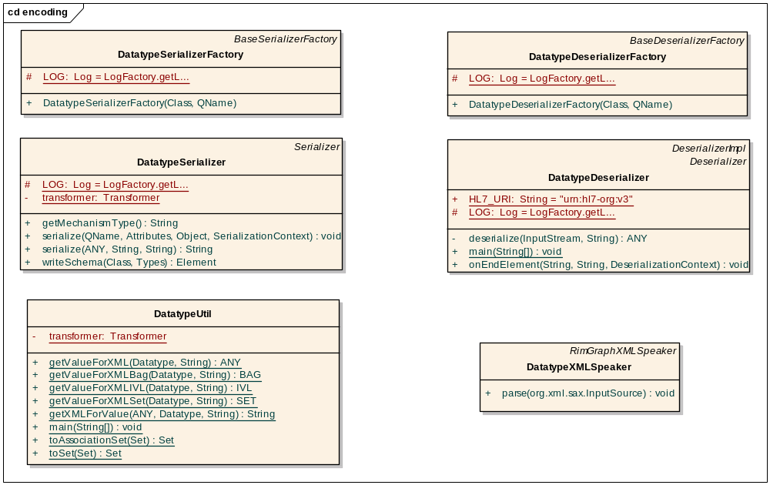
Figure 2 HL7 v3 data type Serialization Framework
Similar to the process used in the Globus generated Java Beans, HL7 v3 Data Type Serialization Framework provides sufficient functionality to use these Java classes in the service and client code, and have them automatically serialized and deserialized to and from the GRID.
DatatypeXMLSpeaker provides the functionality to separate the Java Beans themselves from the serialization process. The HL7 data type Serializer and Deserializer make use of this functionality by providing the necessary hooks from the Globus infrastructure.
The components used to support this functionality are shown in the "HL7 v3 data type Serialization Framework" graph. The Factory classes’ sole responsibility is to be hooked into the underlying Axis framework, and return an appropriate instance of the Serializer and Deserializer classes as needed.
We create the example GRID service called hl7v3datatypeService, which capable of sending HL7 data type object II or CD from GRID client, and hl7v3datatypeService GRID service receive the Object II or CD, and construct new II or CD object, sent back to the client.
Service side interface will be

public interface HL7DataTypeI {

/**
* parse II in, print out, and parse II back
*
* @param ii
*/
public org.hl7.types.II echoII(org.hl7.types.II ii) throws RemoteException ;

public org.hl7.types.CD echoCD(org.hl7.types.CD cD) throws RemoteException ;

}
The implementation of method echoII will be
public org.hl7.types.II echoII(org.hl7.types.II ii) throws RemoteException {
try {
System.out.println("The GRID service side receives II from Client, its value = " + ii);

org.hl7.types.II new_ii = gov.nih.nci.caxchange.hl7v3datatype.util.DatatypeHelper.newII("new_root", "new_extension");

return new_ii;
} catch (Exception e) {
throw new RemoteException("Unable to generate quote: " + e.getMessage());
}

}
echoCD method also has similar implementation.

